**CLL:113-Tut-5**

***Multivariate Non-linear Algebraic Equations:***

**Q1.**

Use Newton Raphson Method find the solution of

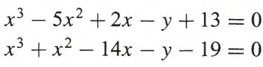

with the help of excel

1. Using (x(0), y(0))=(8,10)
2. Using (x(0), y(0))=(50,60)

Q2. Consider the problem of finding the intersection points of the sphere $x^{2}+y^{2}{+z}^{2}=4$, the circular cylinder $x^{2}+y^{2}=1$, and the elliptical cylinder $4y^{2}{+z}^{2}=4$ with the help of a computer program involving multivariable Newton Raphson method. Use (x(0), y(0) , y=z(0)=(1,1,1). Draw the true error and the relative errors with iteration step.